IMPACTING CHANGE ONE GIRL PER TIME…

THE ANNUAL REPORT 2015

Table of Contents

Chairman’s Message……………………………………………….....3
Coordinators ‘Report……………………………………………………4
About the Foundation…………………………………………………5
Board of Trustees ……………………………………………..………..6
Our Impact………………………………….……………………………..8
Leadership training and starting small……………………….10
PBO Foundation in Numbers………………………………………13
Testimonials………………………………………………………………..14
Pictures……………………………………………………………………...15
Gratitude…………………………………………………………………...17.

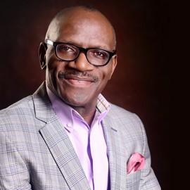
BOARD CHAIRMAN’S MESSAGE

It has been ten years since the passing of our dear Pastor Bimbo Odukoya. Whilst we celebrate her legacy; we are completely invested in ensuring we live in a world of equal opportunities for women everywhere, particularly in Africa.
This is why in the last ten years The PBO Foundation has committed itself to the protection and empowerment of the girl child and vulnerable women, a commitment to rescue, empower and protect that has found expression in multiple projects including: HOPE HOUSE, a temporary safe house and rehabilitation center for victims of domestic violence and sexual assault; the Peer Education for Prefect’s project which focuses on capacity building for leadership and good gender relations; S.H.A.R.P, the Sexual Harassment and Rape Prevention for tertiary institutions initiative, and Girls Empowered, an outreach directed at empowering high school students with 21st century practical life skills.
Today’s world presents unprecedented amounts of opportunities for girls and women everywhere. We have a female Prime Minister in the UK and another on the verge of the presidency in America. In Africa, we have more and more women occupying positions of leadership in public and private life. What we must do is work to remove the impediments, the longheld traditions and cultural practices, the so-called glass ceilings that hold some girls and women back. What we must do is leverage on technology to open up new spaces for girls and women across the world, particularly in Africa. We hope that you would continue to support us in doing these and more. We are here because you give. Help us do more.

Taiwo Odukoya
Chairman, Board of Trustees.

COORDINATOR’S REPORT

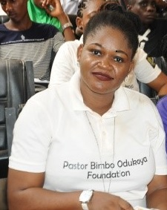
I consider it a great privilege to be a part of the Pastor Bimbo Odukoya Foundation at this time; to witness, firsthand, the impact it is making in the lives of girls and women across Lagos, Nigeria and beyond.
The foundation clocked 8 years in 2015, and in the last three years it has narrowed its focus to rescuing, protecting and empowering the girl child and vulnerable women. This focus necessitated the restructuring of Hope House, a safe house and shelter with a commitment to victims of domestic violence and sexual assault, a project we are particularly proud of. Our first client walked in in July 2015 with an 8 month old daughter who had been sexually abused by her father. Since then, the shelter has been a refuge to ten (10) clients with eleven (11) accompanying family members such as mothers, sisters, and brothers, some of whom have once again become fully functional members of society.
We have grown as a Foundation, and have forged meaningful collaborations to further enhance the work that we do.
Our strategic focus also got us to improve our work with the secondary schools, by providing a leadership and healthy gender relations training (PEER EDUCATION FOR PREFECTS), to cover the intergenerational leadership deficit.
The peer education for prefects (PEP) began as a leadership summer camp for school prefects with 46 students from six (6) public schools in Lagos, Nigeria.
As an outcome of our activities, at the PEP summer camp, the schools testify to a better focused group of prefects. Today we have more schools reaching out to us for similar leadership capacity building.
Whilst more projects, such as Sexual Harassment, and Rape Prevention, as well as Girls’ Empowered will be launched in 2016, ground work has begun,
The memorial service to honor the Late Pastor Bimbo Odukoya was a huge success, as we had people who were certain in their heart that she lives on, as her legacy truly has stood the test of time.
All of these projects cost time, effort and money to execute, and I am grateful to the volunteers, and partners who give to this work. We look forward to doing more with you. May we never turn away from helping a woman or girl, because we lack the resource to do so.
Osasu Paul-Azino

ABOUT THE FOUNDATION

P
Pastor Bimbo Odukoya Foundation (PBOF) is a not for profit, non-governmental, independent faith- based organization in Nigeria that provides information, resources support and training to women and youth particularly young girls in disadvantaged communities across Nigeria.
PBOF is a legacy foundation, established in the memory of Bimbo Odukoya, a woman and a girl’s right advocate, and national merit award winner, who died tragically in a plane crash in 2005. The foundation, established 2007, has continued the work she started in Muslim and Christian communities.
It envisions a world in which every woman and girl-child is not only safe, but empowered to be impactful members of society.
In previous years, this was accomplished primarily through the continued broadcast of “Single & Married” program on television, radio and cable stations across the world, keeping her published works in circulation and developing other publications from her library of journals and teachings.
Since its incorporation in 2007 as a faith-based, not-for profit, non-governmental organization, the Pastor Bimbo Odukoya Foundation has provided succor to indigent women and girls, some of whom have been victims of unwanted pregnancies and in need of financial and medical assistance. It has organized several empowerment programs for students in secondary and tertiary institutions with a view to raising well rounded future leaders. It has also provided scholarships for indigent students at all levels of educational pursuit.
In 2008, PBOF established Hope House, a shelter and rehabilitation center for victims of various forms of domestic and sexual abuse.
The Foundation frequently embarks on an assessment of the prevailing needs of its focal group and amends its offerings accordingly. Some of its initiatives include:
• The Hope House
• Peer Education for Prefects (PEP) Summer Camp
• Girls Empowered
• Sharp 4U
Pastor Bimbo Odukoya had a passion to see single men and women live their lives to the fullest potentials and she always taught that God is in the business of second (and as many) chances. In line with her philosophy, PBO Foundation started Hope House in 2008, a shelter/safe house for abandoned young pregnant single females, who though they made poor decisions in their relationships, do not want to have abortions. Hope House in 2015, with approval from the Lagos state, Ministry of Youth and Social Development, was restructured to be a Safe House for Survivors of Domestic violence and Sexual Assault.
The Foundation also engages in Advocacy projects organized in educational institutions to teach and guiding students in making life-enhancing choices and decision

BOARD OF TRUSTEES

Pastor Taiwo Odukoya
Pastor Taiwo Odukoya, the chairman of the Board of Trustees, is the founding and senior pastor of The Fountain of Life Church, Lagos – a church with a membership in excess of 8,000. He holds a degree in Petroleum Engineering and worked for 12 years with the Nigeria National Petroleum Corporation (NNPC) until his voluntary retirement in 1994 to concentrate on the ministry God had committed to him. A firm believer in the potential of his country Nigeria, Pastor Taiwo constantly seeks or creates avenues to raise leaders for every sphere of national life. An accomplished author, his heart beats continuously

Mrs. Ibukun Awosika
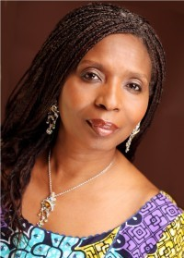
Mrs Ibukun Awosikais the Chairman, Board of Directors, First Bank of Nigeria Limited, Nigeria's premier and most valuable banking brand. She is also the founder and Chief Executive Officer of The Chair Centre Group. The companies within the group include: The Chair Centre Limited, Sokoa Chair Centre Limited, Furniture Manufacturers Mart, TCC Security Systems and Cubes and Boxes Limited. These companies are involved in manufacturing, retail and bank-way security systems services.
Ibukun chairs a number of corporate and not-for-profit boards amongst which are: House of Tara International and Afterschool Graduate Development Centre (AGDC), a facility which she promoted to help address youth employability and enterprise issues in Nigeria. She sits on the boards of Digital Jewel Limited, Cadbury Nigeria Plc., Convention on Business Integrity (CBI) and the Nigerian Sovereign Investment Authority. She was Chairman, FBN Life Assurance Limited, FBN Capital Limited and Kakawa Discount House Limited
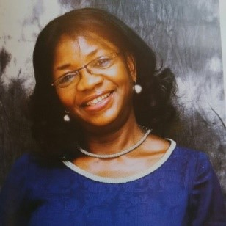

Mrs. Lara Adesanya
Mrs. Lara Adesanya is a Chartered Accountant, Chartered Pension Administrator, and Chartered Tax Administrator. She has first degree in Accounting from Yaba College of Technology and a Master’s in Management from the Abubakar Tafawa Balewa University. Mrs. Adesanya is presently an Executive Director at the Central Bank of Nigeria (CBN)

Mrs. Tolu Ijogun
Mrs. Tolu Odukoya Ijogun holds a Master’s degree in Advertising from Buckinghamshire New University and a first degree in Government with a minor in Public Relations and Advertising from Oral Roberts University, USA. She is a marketing and brand professional. She has worked with a number of multinational companies. A gifted psalmist, with a tribute single album “gifted and proud” to her late mum, she is Pastor Bimbo’s oldest child,

Mr Jimi Odukoya
Mr. Jimi Odukoya has vast business experience in expanding revenues, increasing profit margins, deploying marketing strategy and, competitive profiling and analysis, Jimmy Odukoya is the current Executive Director of FirstCall Institute for Innovation Leadership and Management (FIILM). With an Masters’ degree in Business Administration, and a BSc. in Business Administration and Public Relations and Advertising from the prestigious Oral Roberts University, Jimmy has applied his core business background across different sectors of industry both nationally and internationally, with a vast wealth of working experiences and a holistic approach to business acquired from working in the Oil and Gas Sector, Management Consulting

Mr. Val Ofogba
Mr. Val Ofogba, is a legal practioner, principal partner of Lawsprings &co, with over three decades’ experience in litigation, with specialty in land matters. a member of the presidential technical committee on land reform since 2011. he has received awards from the African Institute of Entrepreneurship, amongst several others. He serves as the secretary to the board.

OUR IMPACT
H
ope House in May 2015 received approval from, the Lagos state Ministry of Youth and Social Development to run a temporary rehabilitation and safe house for, victims of sexual assault and Domestic violence for females of all ages.
Ten (10) clients with eleven (11) accompanying family members received shelter, feeding, medical care, education, health/forensic, legal and physco-social support.
The shelter comprising of 4rooms is a 20bed apartment,furnished with offices, a reception, sick bay, classroom, a living and dining room, housing the domestic violence and sexual assault/defilement cases separetely.
We have had tragic stories of defilement of a 15year old by her stepfather, the culture of silence, been so predominate kept this child in this situation for two years plus. Afraid, and needing constant reassurance, she stepped away from her home, with law enforcement taking into custody her step-father and mother.
Rehabilitation process, have seen 2 women settling into apartments of their own, with the help and support of the Eight Foundation. We provided financial support to start a business, to assist her with taking care of her 4 children.
With Defilement sometimes comes pregnancy. In the 10 clients, 2 teenagers were with pregnancy on arrival at the shelter, hence leading to a collaboration with the ministry of health via established general hospitals.
The PBO Foundation works closely with several rescue agencies and ministries. It also gets cases referred to it by other NGOs. The Foundation is a member of the Child Protection Network (CPN), an offshoot of UNICEF, Nigeria.
Collaborations include;
- Lagos State Ministry of
Youth and Social Development (MYSD)
- Lagos State Ministry of
Women Affairs and Poverty Alleviation (WAPA)
- Lagos State Ministry of Education
- Lagos State Ministry of Justice
Domestic Sexual Violence Response Team (DSVRT)

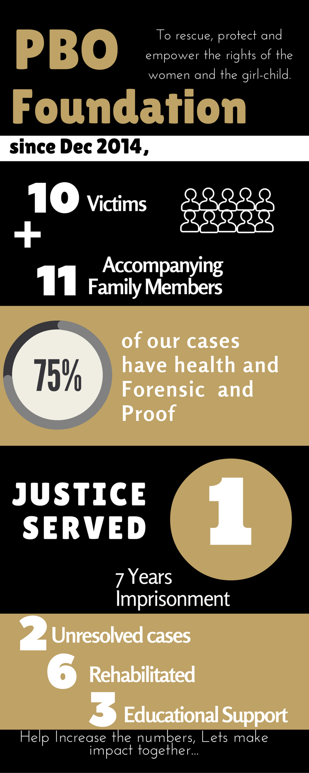
OUR IMPACT MATRIX

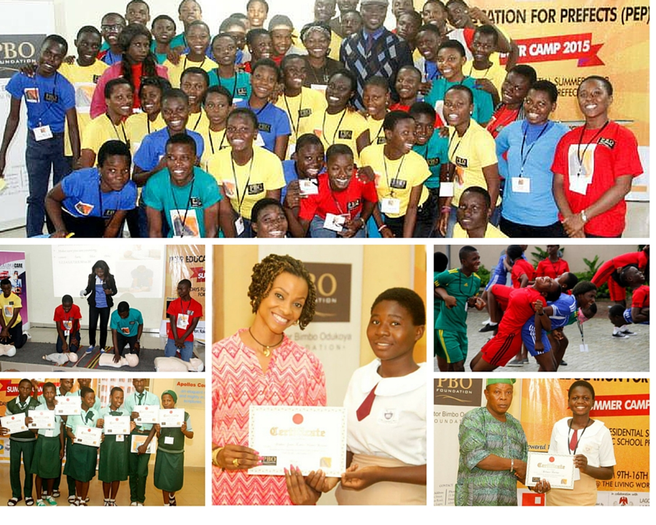

LEADERSHIP TRAINING AND STARTING SMALL…

Peer Education for Prefects (PEP) Summer Camp, held in August 2015, as an 8-day fully residential summer camp for prefects in public senior secondary schools.
PEP is a civic education and youth leadership initiative using traditional/historical leadership structures in secondary schools as a vehicle for developing leadership potential, raising awareness and civic responsibility to equip aspiring young leaders to engage in decision and policy making at a young age
The vision of the PEP Summer Camp is to raise a generation of leaders with the requisite mental, social and moral capacity to affect their world. The project was borne of the realization that there are no targeted leadership building programs for developing the leadership potential of the younger generation, so we created a focus on the Public-school prefects and positioning them to be role models to their peers and junior colleagues.
The summer camp played host to very qualified facilitators, who took classes on goal setting, peer education, sexual responsibilities, etiquettes, and financial literacy. All these were taught and practiced in a serene environment with creativity writing classes and dance.
44 students from6 schools in school district 4 & 6 participated, and there have been resounding testimonies from PEP:
“I have learnt about my rights. How to make the right personal and career decisions, about leadership and how to improve the way I talk. I have learnt
a lot of things about myself.”
— Temitope Balogun, Head Girl (2015), Wesley
Girls Secondary School, Yaba- Lagos. Nigeria

One of the guest speakers also had this to say about the programme:
“The thing about teenagers and youths is that they lack direction. They lack role models. We bring them here together to learn leadership and to ensure that they take it back to their schools and pass it on to their colleagues.”
I think it is great.” ___ Tricia Ikponwonba, Founder/project lead www.stayinschoolng. Lagos. Nigeria

PBO FOUNDATION IN NUMBERS

TESTIMONIALS- What people say about us…
“NGO’s must function together. When we couldn’t provide shelter, we reached out to the PBO Foundation, and with its thorough and unique process, gave the pregnant teenager HOPE. I am impressed with their work.”
— Mrs Amaka Awogu, Executive Director, Child Dignity Foundation

“I am a financial partner, and can attest to the laudable work of the PBO Foundation, as it is indeed giving a life line to women who ordinarily don’t have a lifeline. One cannot place value on it.”
— Mrs Olufunto Igun, Chief Executive Officer, Corona Schools Trust. Lagos

“Our partnership with Pastor Bimbo Odukoya Foundation is premised on the similar objectives that we share. This is to ensure that the needs of victims of sexual and gender based violence are adequately met. We also embark on sensitization and awareness campaigns in higher institution as we believe that prevention is the most efficient way of reducing the incidences of SGBV in Lagos State.”
— Mrs. ‘Lola Vivour-Adeniyi, Coordinator, Domestic Sexual Violence Response Team (DSVRT), Ministry of Justice, Lagos

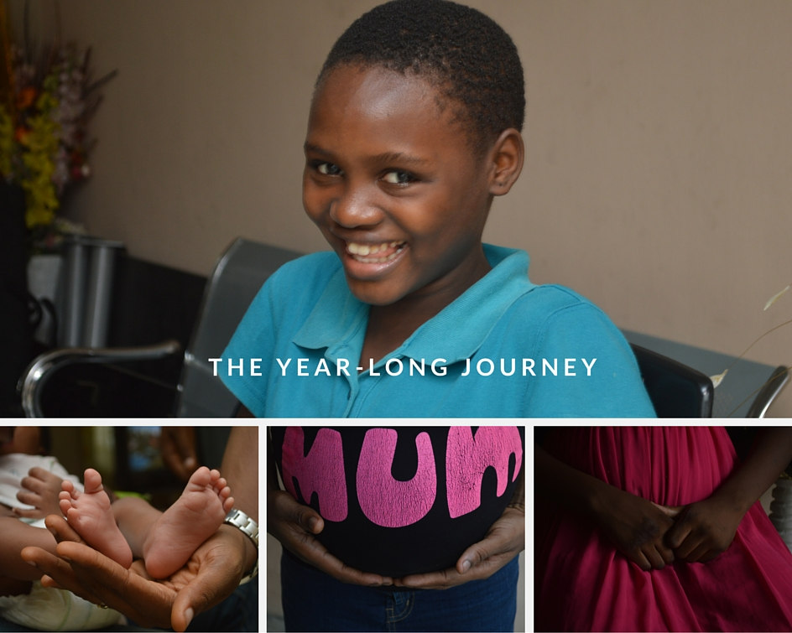

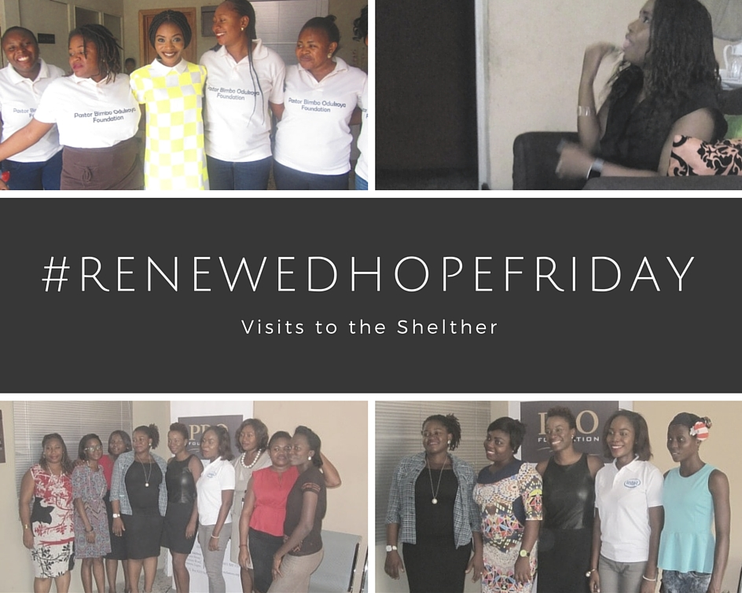

GRATITUDE
Sincere appreciation goes to our Partners, whose names are too numerous to count, who individually give to support and aid the work.
Professionals such as;

Ms. Thelma Ekiyor (Afrigrant resources.)
Mr. Taiwo Akinlami
Mrs. Kemi Sowemimo
Mr. Kunle Soriyan
Mrs. Tiwa Soriyan
Mr. Seun Shobo
Mr. Ekundayo
Mrs. Awolowo
Mrs. Abisoye Akinola
Ms. Ukalina Opuwari and the Society for performing arts of Nigeria (SPAN) team Mr. Temitope Awolowo
Mr. Toni Kan & Mrs. Peju Akande of SABINEWS ( Radi 8 Limited)
Mr. Muktar Mohammed
Mrs. Moji Aribaloye
Mr. Niran Adedokun
Mr. & Mrs. Megbope.

Corporate Bodies such as;

MTN Foundation DUGO Limited
Chair Centre Limited

OUR TEAM
Coordinator Osasu Paul-Azino
Programmes and Partnerships Aderonke Oyelakin

Project Officer (HOPEHOUSE) Funmi Adejumo
Social Worker Ikwo Arikpo

Care giver Elizabeth Ogbolu
In -House Psychologists Funmi Adejumo
Volunteer Psychologists Ayo Adedeji

Our sincere gratitude to our partners;

Azubuike -Orieukwu Ifeoma | Britto-Oluwasegun Oluwatoyin | Adeniyi Olalekan
Sunmonu Damilola | Uyofor Jennifer | Igabari Chukwuemeke
Apara Bolaji | Olaoye Modupe | Fadahunsi Folakemi
Arawole Oluwagbemi | Kehinde Olusola | Ihetimann Allen
Bewaji Bolatito | Shenbanjo Wole | Areogun Adekunle
Ogban Olah | Obafisoye Olayinka | Oyinda Martins Nee Adakomola
Fisher Abosede | Bilewu Omoyele | R.O Agwae
Onalaja Temilola Aderonke | Fayemi Fiyinfoluwa | Oruene Harold
Imuezerua Efemena | Abiodun Adebimpe Julian | Onafowokan S.Abimbola
Ogungbe Mojisola | Kumolu Bukola | Idongesit Increase
Obikoya Anne-Marie | Abodo Okiemute Elohor | Ajayi Yetunde
Erikitola Oladapo | Enosegbe Victor | Adeyemi Adesola Franca
Kujembola Michael | Ojo Titilayo | Adeshola Esther
Ilori Olufunke | Johnson Didi | Aigbonohan Felix
Mordi Roseline | Alao Oluwasegun Samson | Ekeabu Mary
Kujembola Mojisade | Oloyede Umana | Soremeku Olufemi
Ofoma Nkechi | Olutomiwa Gbolahan | Olabanji Korede
Osiemete Vincent | Tiwalade Soriyan | Olatunji Oyindamola
Alake Oluwakayode | Okusanya Oritoke Adijat | Kolawole Olowoyelu
Agoha Chinelo | Sadije Taiwo | Lawson Olumide
Oluwasanmi Temitope | Peters Funmilayo | Yomi Oyeniyi
Falana Abimbola | Akinola Damilola | Ikuesan Stella
Ehimen Otei |  | Paul Balogun Bridget
Shoyoola Olaide |  | Akinoso Abiola
Pratt Jide |  | Adio Moses
Sone Osakwe |  | Amuni Olayinka
Odusomu Olufemi |  | Olanrewaju Funmilayo
Etiwe Dennis |  | Aruna Adebimpe
Ikeaba Milton |  | Bankole Helen Olubunmi
Sadiq Dapo |  | Olukoya Kofoworola
Evans Liseneno |  | Adeoye Bakre
Ighofose Andrew |  | Afolabi Olusola
Onifade Oluwaseyi |  | Esan Bolape
Alade Airat |  | Naka Noah J
Echendu Adaora |  | Bailey Alfred Gbolahan
Oyekusibe Funmilayo |  | Osakwe Soyem
Adebayo Osazuwa Philomina |  | Lawson Omotola
Ayinde Adetola |  | Jokotade Eniyan Funmike
Iroko Adewale Ibiwunmi |  | Dada Adeteju
Dada Mayowa |  | Elebiyo Kemi
Olusanya Olufunmilayo |  | Odigie Festus
Omole Abidemi |  | Adeye Adesanya
Olusanya Oludunmo Paul |  | Abraham Akinropo
Shanu Tunde |  | Olugbemi Kehinde
Nwabuoku Ikechukwu |  | Akinpelu Adekunle
Utulu Ozena |  | Ajayi Abimbola
Ogunade Adeola |  | Okoabah Uche
Rojugbokan Bayo |  | Adeosun Opemiju
Adedeji Kehinde |  | Kayode Comfort
Porbeni Micheal Doubra |  | Dapo Ibironke
Adejumobi Kayode |  | Onabanjo Gbenga
Bankole Samson |  | Fadelu Florence
Amodu Anthony Adebisi |  | Mohammed Muktar
Dike Maltilda |  | Odutola Titilayo D.
Asaam Sarah Korobraebi |  | Sholuwa Faith
Alaka Funmilayo |  | Adeyemi Bukola
Akintayo Idris |  | Udeh Elizabeth
Okoloh Peter |  | Adebayo Bolanle
Sobade Modupe |  | Madanedon Abiodun Oluwayemisi
Iwere Toritseju |  | Sanlola Olaitan Felicia
Pupuru Temitope Eliizabeth |  | Daramola Olakunbi
Atobatele Oluwatosin |  | Somoye Olusola
Kadiri Vivian |  | Balogun Biodun
Odebunmi Damilola |  | Enebeli Cornelia
Akogo Aderemi Adebimpe |  | Eyo Tolu E.A
Iwasanmi Olusola |  | Ewete Oluwatoyin Patricia
Osekita Mayowa |  | Uchendu Afoma
Barshine Goriola |  | Adebayo Nkem Lawretta
Awoniyi Adeoshun Adebayo |  | Salako Bolanle Cecilia
Osagie Jerry |  | Rich-Babalola Thankgod
Adenuga William Olatoye |  | Obiakpu Amaechi Christian
Mokalo Joy |  | Otenigbagbe Odewale Ronke
Tetteh Foli Babay |  | Egwuagu Chinwe
Ehizojie Omobolanle A. |  | Okulaja Ololade
Ogunduyile Edith Ebun |  | Awolola Olanike Omolabake
Yomi Oyeniyi Adenike |  | Ransome-Kuti Bose
Ohaeri Modestus |  | Onabanjo Ademola Adeyemi
Okelana Funmilola |  | Mosaku Adebisi
Ighofose Anuoluwapo |  | Okosun Elizabeth
Peters Adenike |  | Odiase Titi
Uchibuolu Ifanyi Edith |  | Ifidon Osas
Christopher Mary-Magdalene Precious |  | Ekpah Franklin Onyenichie
Oluyide Yetunde |  | Falemi Olawunmi
Omotola Emmanuella Olajumoke |  | Okoro Gladys Ajiri
Igbonaju Anselm |  | Akinboyewa Adenike
Solarin Babajide |  | Matanmi Owolabi Fred
Philip Abioye |  | Edun Oluwatoyin
Karkitie Sandra |  | Ogundele Ikeola. O.
Njoku Eunice |  | Adeyemi Temidayo
Gabriel Blessing |  | Igun Olufunto
Fajemirokun Kemi |  | Onunkwo Hilary
Fatunmbi Damilola |  | Ajayi Love Tejumade
Ezekpo Funmilola |  | Adelekan Adebukola
Adebayo Stella Busayo |  | Omolere Omotayo Justine
Ubiebor-King Aghogho |  | Alalade Oluwadamilola Adeola
Olakanmi Olufunke |  | Olaoye Modupe
Akinola Taiwo Oluwa Toyin |  | Okemuyiwa Oluwatosin
Aloko Ayodele |  | Obadina Florence
Omoruyi Josephine |  | Taiwo Adeola
Edward Odion Martha |  | Oboh Precious.O.
Davies Florence |  | Eduale Clara
Ajileye Olajumoke |  | Owobu Violet
Olanrewaju Adepeju |  | Oyesanya Abosede
Julius Oginni Modupe Oluwa |  | Oseni Olatokunbo
Shonibare Mosun |  | Onikoro Temitope
Okwuike Ifeoma |  | Nwosu Godson
Alli Olufunmilayo S. |  | Iduhom Freda
Adeoye Temitope |  | Rasheed Titilope Abolore
Ojo Babatunde |  | Phillips Lolade
Obiri Bolatito Temiloluwa |  | Odukoya Oluwatoyin
Oladimeji Folake |  | JIMOH ALEEMAT FOLASHADE (Ms)
Adeyemi Olubunmi |  | FEGHA OYINBRA (Ms)
Ikpehae Debbie |  | Oshundiya Temitope
Nathan E. Joy |  | Oyeleye Ololade
Famurewa Adedolapo |  | Andrew Ifeanyi Catherine
Longe Abigail |  | Okuteh Nkechi Catherine
Oloke Patience |  | Omomije Abidemi (Mrs)
Kehkume Edith |  | Alabi Ibironke
Abati Adenike |  | Jaiyeola Oluwaseun Georgina
Williams Lindsay |  | Ebire Ayooluwa
Olonade Oluwatoyin |  | Ose-Lato Adetutu
Isibor Oghogho Mercy |  | Akintoye Tolulope
Owoeye Taiwo Oluwaseun & Janet Lola |  | Gbogidi Ebakoren Rosemary
Soriyan Olakunle |  | Adegunwa Omowunmi
Olowu Rekia |  | Adegbite Adesola
Adeoye Adebola |  | Adebayo Oluwakemi
Akano Titilope |  | Ajayi Olayemi Omolara
James Richard |  | Aloba Funsho
Ogunaike Olusola |  | Onwenu Onyeka
Nkenchor Florence Amaka |  | Isiguzo Goodness Ada
Ezeukwu Victoria Ifeyinwa |  | Popoola Winifred Edirin
Mogoga Blessing |  | Okonmah Kehinde
Oyedepo Oluwatosin |  | Obadina Phillip
Nzegwu Ngozi Adago |  | Achodo Joy Gift
Adeniran-Adedokun Nkem |  | Adekoya Joyce Olubunmi
Aboyeji Adeola |  | Orga Azaana
Adeyanju Funmi |  | Mokalo Comfort
Olulana Fehintola |  | Aluko Kikelomo Mojisola
Olomola Adeyanju |  | Daramola Adetutu Olanrewaju
Shodunke Olanike A. |  | Kemmy Megbabi
Olaegbe Tomilola |  | Oyewunmi Anthonia Kehinde
Akila Stella Olubukonla |  | Adeyemi Funmilayo
Chesa Ikedichukwu |  | Danmegoro Omolola
Adams Oluwatoyin |  | Adebeshin Olayinka
Nwobodo Mary Chikodi |  | Adeniyi Adetutu
Lawal Taiwo Aduraseun |  | Balogun Oluwasemilore
Omolu Favour Nkechi |  | Okor Arit.
Bamigbola Oluwakorede |  | Alaba Motolami Abosede
Ikpewujo Ifeyinwa |  | Otuniga Kehinde .B.
Umana-Ikpeawujor Victoria |  | Tope Adekunle Olayemi
Olugboji Oluremi |  | Olukoya Oladipo
Igbeta Kfm |  | Akintola Funmilayo
Ogundipe Ayodele |  | Sadiq Bolanle Bukola
Kazeem Modupe |  | Charles Ukeme
Jeremiah Mercy |  | Mrs Philomena Awosika
Omotayo Omowumi |  | Pastor Kunle Areogun
Madu Adaobi |  | Abiodun Oladapo
John Franca  Adeosun Opemiju  Kayode Comfort  Dapo Ibironke (Nee Olulana)  Onabanjo Gbenga  Fadelu Florence  Mohammed Muktar  Odutola Titilayo D. (Nee Damilola)  Sholuwa Faith  Adeyemi Bukola  Udeh Elizabeth  Adebayo Bolanle  Madanedon Abiodun Oluwayemisi (Nee Okedare)  Sanlola Olaitan Felicia  Daramola Olakunbi  Somoye Olusola  Balogun Biodun  Enebeli Cornelia  Eyo Tolu E.A  Ewete Oluwatoyin Patricia  Uchendu Afoma  Adebayo Nkem Lawretta  Salako Bolanle Cecilia  Rich-Babalola Thankgod  Obiakpu Amaechi Christian (Mr)  Otenigbagbe Odewale Ronke  Egwuagu Chinwe  Okulaja Ololade  Awolola Olanike Omolabake  Ransome-Kuti Bose *  Onabanjo Ademola Adeyemi *  Mosaku Adebisi  Okosun Elizabeth *  Odiase Titi  Ifidon Osas  Ekpah Franklin Onyenichie  Falemi Olawunmi  Okoro Gladys Ajiri  Akinboyewa Adenike  Matanmi Owolabi Fred  Edun Oluwatoyin  Ogundele Ikeola. O.  Adeyemi Temidayo  Igun Olufunto  Onunkwo Hilary  Ajayi Love Tejumade  Adelekan Adebukola  Omolere Omotayo Justine  Alalade Oluwadamilola Adeola  Olaoye Modupe  Okemuyiwa Oluwatosin  Obadina Florence  Taiwo Adeola  Oboh Precious.O.  Eduale Clara  Owobu Violet  Oyesanya Abosede  Oseni Olatokunbo  Onikoro Temitope  Nwosu Godson  Iduhom Freda  Rasheed Titilope Abolore  Phillips Lolade  Odukoya Oluwatoyin  Jimoh Aleemat Folashade (Ms)  Fegha Oyinbra (Ms)  Oshundiya Temitope  Oyeleye Ololade  Andrew Ifeanyi Catherine  Okuteh Nkechi Catherine  Omomije Abidemi (Mrs)  Alabi Ibironke  Jaiyeola Oluwaseun Georgina  Ebire Ayooluwa (Ms)  Ose-Lato Adetutu  Akintoye Tolulope  Gbogidi Ebakoren Rosemary  Adegunwa Omowunmi  Adegbite Adesola  Adebayo Oluwakemi  Ajayi Olayemi Omolara  Aloba Funsho  Onwenu Onyeka  Isiguzo Goodness Ada  Popoola Winifred Edirin (Mrs)  Okonmah Kehinde  Obadina Phillip  Achodo Joy Gift  Adekoya Joyce Olubunmi  Orga Azaana  Mrs. Mokalo Comfort  Aluko Kikelomo Mojisola  Daramola Adetutu Olanrewaju  Kemmy Megbabi  Oyewunmi Anthonia Kehinde  Adeyemi Funmilayo  Danmegoro Omolola  Adebeshin Olayinka (Ms)  Adeniyi Adetutu  Balogun Oluwasemilore (Ms)  Okor Arit.  Alaba Motolami Abosede  Tetteh Foli Babay  Ehizojie Omobolanle A. (Mrs)  Ogunduyile Edith Ebun  Yomi Oyeniyi Adenike  Okunrinboye Olu (Arc)  Okelana Funmilola  Ighofose Anuoluwapo  Peters Adenike (Mrs)  Uchibuolu Ifanyi Edith (Mrs)  Christopher Mary-Magdalene Precious  Oluyide Yetunde  Omotola Emmanuella Olajumoke  Igbonaju Anselm  Solarin Babajide (Mr)  Philip Abioye  Karkitie Sandra  Njoku Eunice (Mrs)  Gabriel Blessing  Fajemirokun Kemi  Fatunmbi Damilola (Ms)  Ezekpo Funmilola (Mrs)  Adebayo Stella Busayo Mrs.  Ubiebor-King Aghogho  Olakanmi Olufunke  Akinola Taiwo Oluwa Toyin  Aloko Ayodele  Omoruyi Josephine  Edward Odion Martha  Davies Florence  Ajileye Olajumoke  Olanrewaju Adepeju  Julius Oginni Modupe Oluwa  Shonibare Mosun  Okwuike Ifeoma  Alli Olufunmilayo S.  Adeoye Temitope  Ojo Babatunde (Mr)  Obiri Bolatito Temiloluwa  Oladimeji Folake  Adeyemi Olubunmi  Ikpehae Debbie  Nathan E. Joy  Famurewa Adedolapo (Mrs)  Longe Abigail  Oloke Patience  Kehkume Edith (Mrs)  Abati Adenike  Williams Lindsay  Olonade Oluwatoyin  Isibor Oghogho Mercy  Owoeye Taiwo Oluwaseun & Janet Lola  Soriyan Olakunle  Olowu Rekia (Mrs)  Adeoye Adebola  Akano Titilope (Mrs)  James Richard  Ogunaike Olusola  Nkenchor Florence Amaka  Ezeukwu Victoria Ifeyinwa  Mogoga Blessing  Oyedepo Oluwatosin  Nzegwu Ngozi Adago  Adeniran-Adedokun Nkem (Mrs)  Aboyeji Adeola (Ms)  Adeyanju Funmi Mrs.  Olulana Fehintola  Olomola Adeyanju (Mrs)  Shodunke Olanike A. (Mrs)  Olaegbe Tomilola (Ms)  Akila Stella Olubukonla  Chesa Ikedichukwu (Mr)  Adams Oluwatoyin  Nwobodo Mary Chikodi (Ms)  Lawal Taiwo Aduraseun  Omolu Favour Nkechi  Bamigbola Oluwakorede (Mrs)  Ikpewujo Ifeyinwa  Umana-Ikpeawujor Victoria (Mrs)  Olugboji Oluremi  Igbeta Kfm  Ogundipe Ayodele  Alao Oluwasegun Samson  Oloyede Umana Idongesit  Olutomiwa Gbolahan  Tiwalade Soriyan  Okusanya Oritoke Adijat  Sadije Taiwo  Peters Funmilayo (Mrs)  Akinola Damilola  Shittu Olufunmilayo Sarah  Olayera Olufunmike  Olanihun Mobolaji (Ms)  Olaoye Oladipupo  Balogun Omosanya Olajumoke  Peters Anuoluwapo Enitan  Sam-Adekunle Omolola Oreofe (Mrs)  Asuquo Gbemisola (Mrs)  Banjoko Adedoutn Aderonke  Olawoyin Omolara  Adediran Adeola Tolulope  Abiodun Adebisi Oluwaremi  Nkechi Rebina  Honesty A. Kujembola Mrs.  Osakwe Gloria Ozaofu (Mrs)  Awe Temitope  Igbigbi Olubunmi (Mrs)  Akinniidinu Olubunmi (Mrs)  Osunkoya Oluwatosin  Kunle-Ojo Adepeju Oluwakemi (Mrs)  Omowunmi Adeola Fasanmi  Ekah Esther  Kiyesola Adedayo Adebola  Adeyemi Abiola  Asinobi Blessing (Mrs)  Okerayi Oluwabukola  Uzowuru Ifeyinwa (Mrs)  Nwalupue Rita Chinye  Frank Inem  Metibogun Shade Wesley  Sanni Maria Titilayo  Asagba Olayinka (Mrs)  Usunmon Iyesat  Oye-Igbemo Adebola  Oaikhenan Shirley  Willie Atim Etim  Otuony Oluchi Susan  Igwuebueze Sarah John (Mrs)  Afenisume Grace Olufunmilayo  Ojei Esther  Aina Omitade Oluwakemi (Mrs  Philips Ojetunde Kofoworola Anne (Mrs)  Blessing Jibuike Dr.  Adelere S. Oyinade  Sojimi Oluwakemi (Mrs)  Adesanya Funmilola  Ageh Justina Mrs.  Ogundiji Bukola  Ojo Olatokunboh Olufunmilayo (Mrs)  Adeleye Aderemi  Adegoke Olaide  Adeola Bunmi J. (Ms)  Gorden Olakunbi Eunice  Adeyemi Oluwaseyi  Lanre-Oitun Akachi (Mrs)  Ndi Florence (Ms)  Onwochie Theresa (Mrs)  Chukwukere Dous  Damilola Sholeye (Ms)  Daodu Temitope  Onukwo Peace N. (Mrs)  Oguh Alfred Mr  Otudeko Olaide (Mrs)  Esemuru Julie (Ms)  Gloria  Ayinde Fatima Motunrayo  Obisanya K. Victoria (Mrs)  Pastor & Mrs. Alfred Ohiani  Mrs Stella Ohiani  Megbope Olufemi & Ayodeji  Aribaloye Mojisola  Azubuike Nnenne  Moloye Adeola (Mrs) Nee Alabi  Mgbatogu Ron  Temitope Daodu  Toluwani Caroline Odukoya Ijogun  Omole Olakunbi Eunice  Alfred Susan  Oliseyenum John  Ogunbiyi Abiola  Oloke Patience  Mumuni Omowunmi (Mrs)  Thomas Mary  Adedeji Yetunde (Ms)  Elizabeth Onyemem)  Kizito Hannah (Mrs)  Ogunse Abimbola Gold (Ms)  Oriowo Oluwakemi Odunayo (Truecaller Not Picking)  Ogundairo Folashade Abiola (Mrs)  Odukoya Ayodeji (Mrs)  Enitan Femi Obasan  Omadeli-Uwana Oluwatosin  Ofuafia Abidemi Zainab (Mrs) Nee Shogbemi  Onanuga Yetunde (Ms)  Shola-Ojaoba Abimbola  Akinbode Chinenye (Mrs)  Adeola Bunmi J. (Ms) Seperated  Oladimeji Taiwo  Wale-Olaleye Oluwatosin (Mrs)  Olotu Opeyemi (Mrs)  Littletins Count Hadunni  Sonaike Omolayo (Mrs) Nee Feyisayo  Kure Kunuaba  Fashola Temitope Olayinka Truecaller Out Of Coverage  Nnola Lola (Mrs)  Akpan Nkiru (Mrs)  Fatoki Tolulope (Mrs)  Oduneye Olabisi Abiodun (Ms)  Okeagu Ogadinma Esther  Kasim-Olufisayo  Olabode Tomilola Atinuke  Jolaosho Omolola (Mrs.)  Adebajo Temitope Folashade (Mr) *  Oni Omolola (Mrs) Nee Danmegoro  Omikunle Adeola (Mrs)  Akanni Adeola Truecaller  Ayanbadejo Odunayo (Ms)  Adesanoye Kikelomo (Mrs)  Adefusi Opeyemi Florence (Mrs)  Solaja Damilare  Opadiran Emem Ayomide  Ojo Oluremi (Ms)  Olanihun Abisola (Mrs)  Okoloh Evelyn  Jolaoso Olabisi Olawunmi (Ms)  Thomas Esther Kwaghngu (Mrs.)  Oluseyi Ogunlana Adebola Switched Off  Akinkanya Olamide (Mrs) Nee Adeduro  Afonrinwo Adebisi (Mrs)  Ashadele Olabisi  Shittu Esther Oluwatobiloba New Email  Ezeukwu Victoria Ifeyinwa Ms  Adeagbo T Emily Oluremi Ms  Adeleye Mobolaji Mojisola (Mrs)  Chinwe Okagu  Iyasara Constance O. (Ms)  Aiyedun Folakemi  Fale Folashade  Momoh-Sanni Celine  Nkpubre Atim  Allen Abiodun  Harrison Toju Ms  Mogaji Gbemi (Mrs.)  Ayorinde Adefolake Olubukola Ms  Adesanya Seun  Kujembola Honesty(Mrs.)  Adesiyan Olufunmilayo  Akinyosola Olatokunbo Ms  Alder-Hayes Sade Mrs  Adeyinka Susan Omobolanle Mrs  Fayemi Olamide  Oloke Patience  Okikiade Olutosin .A  Ikpor Elizabeth  Olagbaiye Abigail Mrs Nee Longe  Adekoya Deborah Abiola  Mathias Patience Morenike Mrs  Ekpeyong Mary  Ukiri Olubunmi Mrs  Olonta Kate  Modele Olabisi Oluwaseun  Olajide Atinuke Mrs  Adebule Yetunde  Animasaun Abimbola  Adebunmi Yinka Ms  Sobamowo Adebanke A. Mrs  Ogunjobi Abiodun Mr  Alaiyemola Olubunmi Ms  Iyamu Tokunbo Edowaye Ms  Chijindu Oryenkwere Mrs.  Ajai- Ikhile Elsie Mrs  Adeyemi Olamide Mrs Nee Opere  Agwae Regina Mrs  Jack Priye  Alhazan Stella Omolola Ms  Williams Carlton  Okoludo Yvonne Ms  Alake Oluwakayode Mr  Agoro-Ojo Ibironke Mrs  Akeju Folashade  Aladesuru Olamide  Adebowale Olakunmi Mrs  Akinsanya Tola Mrs  Pastor Mrs Okupe Adebisola  Adebowale Wale & Keji Mr & Mrs  Dan-Chigwalu Tolulope Mrs  Oyebola Busola Not Picking  Ogunbowale Olukayode Mr  Badejo Ademola Mr  Obinzu Anthonia Isioma Mrs  Famulegun Titilayo  Ogban Olah Ms  Ofoeyeno Juliet  Hamed-Adefale Adebukola Mrs Nee Daramola  Bola Abimbola Mrs Nee Akinsuyi  Adesina Sara Olukemi Mrs  Ajuwa Destiny Mrs  Obaisa Adetutu Victoria  Alex-Oni Mosebolatan  Elimihele Elizabeth Eji  Keshiro Oluwatosin  Shoyoola Olaide  Adakomola Oyindamola Ijeoma Truecaller Not Picking  Adeyemi Adesola Ms  Osisanya Toyin Mrs  Tinuola Ayobami  Olaofe Moninuola  Obianwu Olutoyin Morohunke Mrs Call Back  Bola Eyitayo Mr  Iwere Toriseju Ms  Osisanya Olayemi Oluwasola Ms  Paul Briggs  Oluseyi Ogusola Mr  Sholuwa Omawunmi Joy Ms  Sekoni Yemisi Love  Okereke Mabel  Agboola Oluwatoyin  Okewumi Titilayo (Mrs)  Ewa Oriri  Okundalaiye Ayodele Mr  Offor Philip Mr  Ulayi Chiamaka Mrs Nee Okechukwu  Asagwara Chioma  Adeniran Isaac Olalekan Mr  Uboh Bassey Joyce  Orungbemi Omowunmi  Taiwo Adenike Mrs  Abanugor Hannah Ms  Adebisi Christana Mrs Nee Jaiyeola  Nwaneze Ifeanyi Anthony  Mekuleyi Omobolanle  Ohue Micheal Samuel  Okeke Chidinma  Osazuwa Philomina  Mamukuyomi Oluseyi Dapo Call Back Wed. Ann.  Solomon Olayemi Mr  Obaro Aramide  Akinyele Alaba (Mrs)  Ifeanyi Mofunanya  Willoughby Tunde  Dafe Joseph Faith  Onyemeziri Richard  Irabuchi Onyimyechi  Osagie Mercy  Agbelege Ayodele Mr  Adekoya Abisola  Iheanacho Timothy  Udobi Patricia Nwanneamaka  Ojo Olanrewaju David  Ekudayo Akintade  Akintaro Emmanuel Akinyemi Mr  Oliseyenum John  Ogedegbe Ese Mr  Adebiyi Temitayo Isreal Mr  John Joseph  Idowu Folorunsho Omotayo  Tapere Joshua  Okoro Kenneth Mr  Omoniyi Omolola Ms  Olupalace Tayo  Jaiyesimi Morenike  Doherty Mark Mr  Olubiyi Funke  Onyegbule Amaka  Dr Ajeh Peter Bernardr  Inim Annie  Sekoni Temitope  Emmanuella Nwosu  Okewale Kehinde Afolake  Lawal Taiwo Aduraseun  Israel John Chinedu Mr  Anthony Goodluck Ijeoma  Abidoye Opeyemi Stephen  Dodo-Williams Joy Gift Mrs  Olaoye Oladipupo Samuel Line Off  Ojo Ugo Chinyere Ms  Oyegoke Oluwatoyin Abiodun Not Picking  Forson Caroline Mrs  Odujebe Olusegun  Duru Chichi Blessing Ms  Kunle & Abimbola Osunkunle  Akiode Oluwadamilola  Oluwakemisola Sophia  Obaoye Aderonke Ms  Akinbusuyi Dorcas Ms  Obiaku Abosede 'F. Mrs  Aminu Yetunde Titilayo Ms  Agboola Daze Mr  Kinidisi Morolake Yetunde  Eguabor Olayemi  Edoho 'Kate  Adesanya Wole  Nwogu Ekene Patience Mrs Nee Okoabah  Fidelis Kenkuwen Marcel  Vanessa Atisele  Okongwu Chinyelu Ms  Moji Williams Mrs  Soyebo Jimi & Fola (Mr & Mrs)  Oyebade Taiwo  Onyibueke Blessing  Odunfa Adedoyin  Okharedia Shirley *  Alabi Imade Olasumbo  Oyedokun Peju Ms  Loveth Evans Ms  Okunade Omobolanle  Irho Mary Ifiegherere Ms  Patience Okocha Ms  Mbonu Helen Equi  Justus Tina Ijeoma Mrs Nee Aquanyo  Ajibola Joseph Kayode Mr  Egbukichi Vera Ms  Arikpo Charity  Mrs Lai Koiki *  Taiwo Eleanor  Dosunmu Mosunmola  Onwudimegwu Buchi  Ojenagbon Anthonia *  Obasi Kate  Ajiboye Oluwakemi  Aadeeko Oyindamola Opeyemi Mrs  Daniel-Somefun Temilade Mrs  Fadipe Oyebade  Ogundipe Oluwayemisi Mrs  Dada Bolanle Mrs  Adewolu Moradeke  Shoyoola Olaseni  Onyemechara Ada  Ade-Philips Abimbola  Ayodele Olubunmi.O.  Obianwu Tolulope Nkiruka  Ogbedobor Evezi T  Effiom Angela Donald Mrs  Longe Oiza Truecaller  Adebeshin Olubukola Ms  Lepe Bukola Mrs  Ikhwuoria Godstime Omobolanle Truecaller Not Reachable  Joseph Oiza  Okoye Nkiru Mrs  Ikotun Temitope  Makanju .C. Oluwakemi  Ayodola Olajumoke  Oyinloye Oluwakemi  Kassim Omobolanle Deborah Mrs  Aina Adebunmi Mrs Adelakun  Ilori Temitayo  Oshundiya Eniola  Atobatele Olutosin Opeyemi Ms  Gbemudu Oby Ms  Omonigho Onome Ms  Mrs Okusanya Temilade  Omodibo Sandra  Anyanwu Lorreta Chioma  Bukunola Mashingo  Babayemi Fehintola Ms  Adejumobi Olubukola -Pretty Fabulous Mrs  Ndulue Joy Uche Mrs  Akinmameji Bosede  Oloruntuyi Tolulope  Elegbede Titilope  Edet Udeme Ms  Adejumo Adebukola  Owoaje Yetunde Foluke Mrs  Alalade Olasumbo Temilade Ms  Moses Samuel  Simisola Motiriwon Mrs  Ogbuigwe Pat Mr  Oyedeji Oluyemisi  Ajaraonye Ozioma Lilian Mrs  Adebowale Monisola  Falemi Abiola  Adedeji Yetunde  Sowande Adetokunbo Oluwadamilola Line Off  Tugbobo Oluseye Julianah  Ogbiko Eniye Ann  Sobola Abimbola Oluwatosin Ms  Onwuachi Esther Oyinsi  Ekpo Christina Ms  Adesetan Bukola Adesola *  Ayilara Olubukola  Adedipe Oluwatoyin  Fabiyi Temitope Abosede Mrs  Unachukwu Blessing Ms  Oke Testimony Kikelomo  Adedayo Aderonke  Odutola Yemi  Shosanya Ololade Mrs  Emmanuel James Aderonke  Onyemeri Chudi  Ikechukwu Nadama Charity  Popoola Oluwatosin Mrs  George-Shaba Gbemisola  Kazeem Modupe Ms  Jeremiah Mercy Ms  Omotayo Omowumi Mrs  Madu Adaobi  John Franca Mrs  Okoko Erinma Glory  Osinuga Comfort  Ashi-Sulaiman Lara Mrs  Ajibowo Oluyinka  Alaba Olaoluwa Mojisola  Ojo Atinuke  Odumosu Sarah  Shonde Olubunmi Mrs  Ogunfidodo Adeline  Adeoye Olubukunola  Oluwashina Tobi  Ohaeri Modestus  Briggs Idayat Omolara Mrs  Briggs Esther Odion Mrs  Ogunjobi Ayotunde Mrs  Fadoju Folusho Not Picking  Adebowale Omolabake Mr  Ifenkwe Chinyere Mrs  Okorie Nne Nnaya  Bayegunsi Kehinde Mrs  T Joy Mrs Nee Ovat  Otunlape Adekemi  Mgbeokwere Chioma Mrs  Onuobia Grace  Folarin Nee Adesanoye Tolulope. T.  Adeoye Olayinka Mrs  Abuath Cynthia Ms  Okoro Chikerenwa Uduma  Ekong Justina  Ikemefuna Bose Mrs  Madubuike Adaeze Chioma Ms  Enang Iniobong  Awolowo Kikelomo Mrs  Idiakhoa Eseohe Stella Ms  Okhiria Damaris  Oladipupo Ibukunoluwa Esther Mrs.  Affia Emma Trucaller  Anyanwu Augustine Funmilayo Omoniyi Mrs  Maria Zotoglo  Oyekusibe Funmilayo Mrs  Kayode Solabomi  Tobi Jane Ms  Benson Ogunsipe Aderonke Adebiyi Mrs  Adedeji Gbemisola Mrs  Akinola Omolayo Ms  Fasheminikan Oluyemisi Omowunmi  Soyebo Elizabeth .O. Mrs  Kazeem Toyin Ms  Koleosho Oluwaseun  Odunuga Adenike Mrs  Abimbola Mrs Nee Obadina *  Agodo Enai Mrs  Owoaje Moranugba Mrs  Odedairo Olubunmi Christiana  Desalu Adesola  Olude Olumayowa Mrs Nee Awonuga  Wariso Stella Ms  Abun Susan Mrs  Osiyemi Abimbola Olonike  Osisanya Olusola Ayodele Mrs  Ogundele Adebanke  Sarumi Ife  Ojukwu Adaku Ms  Mathew Oluwabunmi Preye  Chukwumbah Nnena  Adekoya Adesola  Asagba Mandy Mrs  Afonrinwo Victoria Abiodun  Asoma Bukola  Oguneye Beauty Mrs  Shitta Doris Mrs Nee Ekairia  Ofogba Carol Mrs  Okodugha Evelyn Mrs  Oluwadare Omolola Mrs  Ogunmade Omotola Olufunke  Longe Oluwabunmi  Odewale Oyebimpe  Ifaturoti Ibiyemi Ms  Mosaku Adebisi  Obot Mercy Charles Mrs  Olaide Omowunmi Mrs Nee Kalaro  Ekperigin Patience  Abifarin Joke Line Off  Akinwunmi Damilola Ms  Omoregbee Folasade Mrs Nee Akinyemi  Akindolie Ayomide Ms  Ako Ese Ms  Kehinde Olusola Ms  Okulaja Yetunde Ms  Ezezobor Taiwo Nee Adedotun  Obike Ngozi  Adebajo Titilayo Elizabeth Nee Morakinyo  Ilori Oladele Olabiyi  Shogade Omolara Elizabeth Ms  Adedotun Kehinde  Adeyemi Iyetunde Mrs  Nwannennaya Ijeoma  Umuteme Ewomazino Onome  Oginni Oluwafunke Omolara  Adedeji Adefunke Ms  Garrick Adenike Aderonke Mrs  Osimekun Grace Fehintola  Mrs Oyediran Folasade Nee Ogunronbi  Osazuwa Evbusogie  Alaran Oluwatoyin Ms  Mrs Kussiy-Wanza Patience. O.Unreachable  Azeez Oluwatoyin Victoria  Olaleye Tunde Mr  Fidelis Abuah  Sylvester Ojenagbon *  Olaleye Olubunmi Olukemi  Mowunmi Olowu  Odu Roseline .F. (Mrs)  Jamila Charity Ogah  Adebukola Adebanke Oni  Blessing .O. Okebugwu Ms  Omotayo Odejimi Mr  George Adewale  Pastor Emmanuel Isreal  Omale Akoji Friday Mr  Edith Awosika  Matthew Davies  Rev. Tunde Joshua  Blessing Okorie  Oluwaseyi Olujimi Mr  Jirola Onamuti  Omolara Sobowale Ms  Kanyinsola Abioye Mrs Nee Williams  Ego-Egonwa Omonigho Mrs  Ogunseitan Tolulope  Olubunmi Adams  Tunde Olubunmi Catherine Mrs Nee Osinuga  Oluwafolakemi Fadahunsi  Jerry Tom Ekwere  Nwachukwu Caroline Adaobi Ms  Beatrice Oludiya Mrs  Pastor Debo Adedeji  Mrs Folashade Rojugbokan  Lawal Tinuola (Mrs)  Fola Makinwa  Toki Oluwatobi Opeyemi Mrs  Ijere Ikoro  Mrs Grace Oluwatoyin Aina- Richard  Nina Okorie Ms  Samson Ben Hezekiah  Ojo Oluwakemi  Mrs J.U.F Ananaba  Femi Adebayo  Alade Oluwatoyin Abimbola Ms  Mrs Adiah Okunade  Victor Eyo Jnr Mr  Erogunaiye Yetunde .H. Ms  Idowu Thomas Mr  Ms Ayodele Ambruce  Akande Adekunle Oluwadamilare  Ukpa Ezinne  Victoria Nnenna Ekugo  Doyle Tosan  Tosin Rosemary Kolawole  Dr (Mrs) Modupe Adeyinka .O.  Bukky Bello  Okenwa Loveth .O.  Tunde Ayeye *  Afolake Iyanuoluwa Adelowo  Mrs Gbemisola Numa  Pastor (Mrs) Solabomi Ayo-James  Chinedum O. Akwaradu Mr  Pastor Samuel J.Ekpo  Charles Agbasimelo *  Bosede Abe Isreal  Ibedu Onyebuchi Kevin Mr  Adebayo Olugbenga. E.  Olayinka Osuntogun (Mrs)  Adeola Taiwo  Nadu Denloye  Omotolani Olabanji  Joyce Ikhile  Alade Adenike Oluwakemi  Ayo Oshewona Mr  Luther O. Moses  Oladubu Olakunbi Adetola  Bode Osunkoya  Ijidakinro Tosin  Uguru Oluchi  Uchibuolu Ify Edith  Rosemary Odiatu  Akinbani Olayiwola Mr  Charles Anyasi  Balogun Oluwadamilola  Okagbue Chikaodili Oghechukwu Not Reacahble  Carol Nwankwo Ms  Ajayi Olaide  Somoye .A. Samson  Olumide Ijogun  C.O.A. Adeniji  Oluwasegun Abayomi Alimi  Odukomaiya Adenike P Mrs  Dr Tayo Adeniji  Odusoga Oluwabukola Ms  Mrs Kunmi Adebowale  Ayo Richards  Maduneme Amaka *  Bukola Oyinloye Ms  Prof. Idowu Sobowale  Ogunde Adeneye Mrs  Akinwale Oladunke Naomi Mrs  Okoro Bridget Bawo  Gideon Okon  Ayanbisi Temitope  Olabode Damilare  Maureen Iduhon  Taiwo Oluseyi Awotunsin  Adams, Paul & Glady's  Olaniran Aluko Mr  Noel Johnson Iyere Mr  Joshua Foluke Mrs Nee Ikotun  Uikhenan Iduaoesi Ms  David Olakunle Akintunde  Bolanle Esan  Ogunbosi Elizabeth Omolara Mrs  Oyeniyi Oluwaseyi Arike Off  Mrs Adepeju Opeoluwa Adeyemi  Oluwadun David Olayiwola Mr  Afolabi Olufunmilayo Ms  Abiola K.O  Ayoade Olujoke Olumayowa Mrs Nee Otuniga  Balogun Oluwaseun Mrs Nee Oyekan  Margaret Adekemi Oke Ms  Ibiwunmi Adeyemi Mrs  Ikujuni Olasinbo Racheal  Adewunmi Alayande Sanu Ms  Idam, Ogbonne .N. Mrs  Adeola Onifade  Adeyi Opeyemi Hanna Mrs  Thompson Morounmubo Oluwaseun Switched Off  Mrs Toyin Imoyo  Onichabor Samuel  Obasa Tolutayo May  Vincent Anyanwu Mr  Okoh Edith Ms  Falade Babatunde Favour Mr  Innocent .A. Okojie  Mrs Oluwatoyin Iyadunni Aderibigbe Not Picking  Modele Buroh (Mrs)  Emmanuel Ademola Oyedemi  Oshodi .H.Oluwakemi  Ogunjinrin Omolara Oluwakemi  Adigwe Chiedu Victor  Ann .K. Nwajei Ms  Justin Ihesinachi Nwankwo  Blessing.E. Obaji Ms  Obasuyi Adesuwa  Okeya Olubunmi Cathy Mrs Nee Oladunjoye  Mrs Kehinde Amusa (Rumsewe)  Taiwo Olumide Mr  Rhoda Ofoluwamiyo  Faranti Samson Adewale Mr  Mrs Olusola .O. Adebanjo  Dipo Fakorede Mr  Olufowokan Bukola Ms  Omodibo Sylvia  Ibiwunmi Akinnola Mrs  Oluwatuyi Ayodele Tokunbo Mrs  Mr & Mrs Segun Williams *  Fadekemi Onadele  Ms Bukola Robbin  Onuoha Chinyelu  Ezike Vivian  Bukola Olarenwaju  Oguche Michael  Abiola Hussain (Dr)  Mrs Remi Bolodeoku  Pastor Mrs M.O Shodipo  Patience Akpatre (Mrs)  Kanyinsola Fashina Ms  Adesoga Oluwakemi Ronke Mrs  Victoria Caulcrick Mrs  Bola George - Epebifie  Mrs R.O. Adeyemi  Bola Sanu  Fakiyesi Kehinde Ezekiel Mr  Adeniji Mayokun  Lilian Abigail Osunde Mrs Nee Nzemeke  Pastor Chimezie Azubuike  Ajadi Bambo Oluwadare Mr  Tubosun Olude (Late)  Umeorah Chinelo .B. Ms  Annointed Prince Johnson Mr  Juliet Miebi  Rosemary Gbogidi Mrs  Pastor Taiwo Odukoya  Ushokhai Olushola Mr  Eneda Abolaji.O. Mrs Nee Abolaji  Pastor Blessing Awosika  Racheal.J. Obong Mrs  Adeyemi Bukky Ms  Mordi Omotunde Abisola Mrs Nee Ogunbowale  Biodun Shoderu  Meadows Adebisi Mrs. Nee Adebayo  Afolayan Bolanle Ms  Ojo Titilayo Ms  Ogunkoya Yetunde  Toyin Fajobi Mrs  Valentine Ofogba  Olaode .V.Olufunke Ms  Abekhe Mary Ann  Ogechi .N. Opara Ms  Dumebi Olusoga Francis Mrs  Abimbola O. Akinkugbe  Bamigboye Adeniyi Mr  Olatunde Otunbanjo Mr  Adeshola Adesanya Mr  Mrs Owoeye Janet Lola  Ogunleye Oluwaseun Emmanuel  Otuniga Kehinde .B. Mr  Tope Adekunle Olayemi Mrs  Olukoya Oladipo Mr  Akintola Funmilayo Mrs  Sadiq Bolanle Bukola Ms  Charles Ukeme Mrs  Mrs Philomena Awosika  Pastor Kunle Areogun  Abiodun Oladapo Ms  Daniel Abiodun Faleye  Yomi Onabanjo  Omobola Johnson  Yewande Zaccheaus  Owoseni Joseph Mr  Tiffany Chukwu  Bukola Adejokun Ms  Pastor (Mrs) Bode Dipe  Feyisayo Onabanjo Mrs  Bode Olugbore Olayinka Mrs  Olatunji Sijibomi Mrs  Ade-Ojo Abiodun Olubola Mrs  Patrick Uche  Adekunle Ruth Mrs  Atagana Amen Mrs  Olulana Adeola Mrs  Odulaja Ronke Ms  Alaka Haleema Adetola Ms  Owolabi Oluwasoji  Olufeko Temitope Mrs  Alayande Victoria Olulanu Ms  Amao Kikelomo Enitan Mrs  Subu Giwa Amu Mrs  Olusegun Omobolanle (Mrs)  Ibiwoye Olukemi (Mrs)  Nwanze Ifeanyi Anthony  Salako Adebola Ms  Russel Blessing Mrs  Osinubi Toni Ms  Babalola Richard Adeoti Mr  Kehinde Abisola Ms  Attih Mercy Ms  Osoba Abosede Oluwafunmilola Wrong No  Amaso Nokuthulo F. Amaso Mrs  Wale-Adegite Funmi  Ike Ukamaka  Ajala Oluwayemisi Ms  Ojei Margaret Mrs Nee Ibhazebo  Nwosu Blessing Chidinma Mrs  Chime Elizabeth Mrs  Taiwo Yejide Mrs  Sansa Ronke Ms  Akinleye Bolanle .R. Ms  Oyemade Titilade Seun Ms  Ugonwa Ekugo  Ogungbile Omolola Ms  Paul Idara Ms  Kadiri Oluwatomilola Mrs Nee Sholola  Nnaji Anthonia Mrs Nee Onwamaka  Umana Mfon Grace Ms  Sanni Omolabake Ms  Olowolafe Omolara Ms  Adeleke . S.Oyinlade Ms  Morafa Adeola Tolulope Mrs Nee Adeniran  Inyang Mary Ms  Olaoluwa Abosede Moromoke Mrs  Adesanmi Abosede Ololade Mrs Nee Oginni  Adegboro Adejoke Posola Ms  Owolabi Oluwadamilola Mr  Precious Chinwe Mrs  Shobo Oluwaseun Pastor  Archibong Ini Blessing Mrs  Diaku Pat Mrs.  Oladehinbo Oluwatoyin Olabisi Mrs  Ayinde Adetola Gbemisola Ms  Azeez Olaronke Oluwatoyin Mrs Nee Adeoti  Akintoye Olufunke Mrs  Odiaga Ewea Happiness Ms  Shonola Oluyemisi Mrs  Affam Oby Adaobi Ms  Osamor Joy Onuwa Ms  Craig-Adeniran Oluwatoyin Mrs  Fashola Sura Olatomi Mrs  Jeje Olayemi Ms  Bolarinwa Olubukola Mrs  Tejuosho Adefunmilayo Mrs  Ojo Olabisi Mr  Ekpah Peter Obianuwe Mr  Adu Samuel Mr  Imoru Rachael Taiwo Ms  Okurame Roseline Mrs Nee Asuelimen  Ofoeyeno Joyce Ms  Akinpelu Tolulope Mrs Nee Amosu  Onwordi Partricia Ms  Olugunla Abimbola Mrs  Chidi-Okere Oluwakemi Mrs  Alabi Emo Irene Mrs  Akinsulire Tomi Mrs  Obokoh Vivian Ms  Onjeide Blessing Ms  Adesola Esther Aderonke Ms  Mrs Bailey Oluwakemi  Idowu Victoria Omonye Mrs  F Nello Rita Mrs  F Nello Rita Mrs  Omokhapue Ibironke  Afolabi Modupe Mrs  Adesanya Flora Mrs  Ihedoro Agatha Chidinma Mrs  Akpan Peace Mrs  Ikape Eunice Mrs  Izenegbe Omkhose Tessy Ms  Osiemeje Christy Mrs  Haruna-Sheidi Hauwa Ms  Maku Oluwaseun Ms  Odugbefan Iboro Mrs Nee Umoh  Tonye-Edet Iboro Mrs  Okafor Awele Maureen Ms  Mathias Akudo J. Ms  Kujembola Mojisade Mrs  Johnson Edith Mrs  Joseph Alfred Mr  Asaam Korobraebi Eyibodongha Sarah Mrs  Johnbull Omowunmi Ms  Adekunle Bosede Ms  Azubuike Vivian Mrs  Ogunbosi Ayokunle Mr  Omojowo Iwalesi Olufemi  Duru Kate Mrs  Esan Bolape Olabimpe Ms  Abiola Adetutu Mrs  Faloye Oluwatola Mrs  Chukwudi Aniema Mrs  Adu Olubunmi Mrs  Sosanya Titilayo Elizabeth Mrs  Okorie Toni-Karin Mrs  Boyo Francola Mrs  Ade-Ajayi Toluwanimi  Bada Olubusayo Ms  Ogunseye Busayo Mrs Nee Babayemi  Oyemade Adejoke Olutosin Ms  Sikuade Remilekun Mrs  Osikoya Funmilayo Mrs  Akinbule Florence Olayinka Mrs  Peters Anuoluwapo Tope Mrs  Akinwale Adeshola Ms  Adenipekun Adetoro Idowu  Sanu Omobolanle Mrs  Sam Grace Mrs  Mrs M.A. Allen  Lotun Olufunso Omobolanle Ms  Adams Itunuayo Mrs  Jokotade Enitan Funmike (Miss)  Babatunde Bola Adejoke Mrs  Minakiri Oluwaseun Ms  Amaole Ngozi Ms  Omoteso Olubunmi  Olayinka Olawunmi Mrs  Adetola Funmilayo  Osagiede Tina Ms  Daniel Awele Mrs Nee Ajufoh  Oladapo Oluwadamilola Ms  Peter Thursdaline Ms  Oyetola Oluwafunmilayo Ms  Adebayo Eniola Ms  Ihievbe Precious Thelma Kenny Ms  Ibegbulem Victoria Mrs  Olabiyi Olufunmilayo Mrs  Ozor Sophia Iyore Mrs  Akanbi Funke Abidemi  Pam Salome Simi Mrs  Oluwatosin Abimbola Mrs  Bello Julie Mrs  Ubiebor-King Omotigho Ms  Ogunlana Oluwapero Oluwaseun Ms  Ajuwon Oluyemi Mrs  Ashadele Olabisi Line Busy  Nwadineke Gift Chinyere  Otunlape Adenike Ms  Adetoye Atinuke Ms  Azubule Magdalene Obiasi Mrs  Adeyemi Olubukonla Mrs  Amade Morenike  Ajobi Allison Ms  Edobor Sylvester Mr  Mr And Mrs Lawson  Barr Mandy Asagba  Barr Adepeju  Barr Mulikat  Oyindamola Aina  Dare Izebuno  Sobade Modupe Shola  Oluyemisi Tolulope Femi-Sipe  Adesokan Oluremi Grace  Ayomide Akindolie  George O. Okusanya  Anthony Amodu  Afolabi Oladele  Olabisi Modele  Oyinda Aina  Dayo Adebayor |  | Daniel Abiodun Faleye
 |  | Yomi Onabanjo

